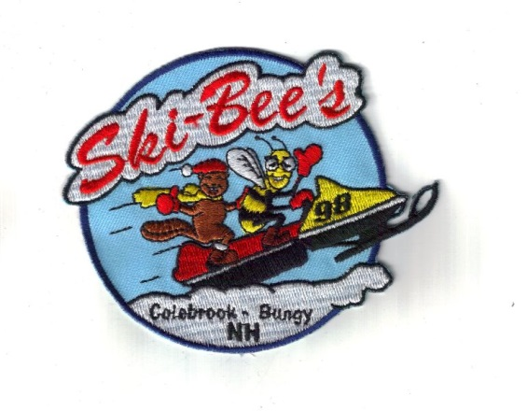
2024 Colebrook Ski-Bee
Snowmobile Club Annual Book Scholarship

Scholarship Rules and Information

The Colebrook Ski-Bee Snowmobile Club will award one book scholarship, in the value of $500.00 to a graduating high school senior who has been accepted at a College, Junior College, or Vocational School or to a College Student who is already enrolled. The student, or their Parents or Guardians must be already a member of the Colebrook Ski-Bee Snowmobile Club for the 2023 - 2024 year.
The Scholarship Committee will review all applications and make its award based upon academic achievement, extracurricular involvement, community service and the quality of the original essay submitted with each application
The 2024 essay should be about what snowmobiling means to you, or about snowmobiling in your state (economy, trails, and environment) in five hundred (500) words or less.
Your complete application package must be received by the Colebrook Ski-Bee’s by May 15, 2024. (PO Box 125, Colebrook, NH 03576) The package must contain the following: your application, letter of acceptance at the college you will be attending, transcript of grades at high school or grade record of the college you are already attending, essay and your recommendations.
All application materials are considered Confidential, and will be limited to examination for their intended purpose only and become property of the Colebrook Ski-Bee Snowmobile Club.
2024 Colebrook Ski-Bee’s Scholarship Committee
2024 Colebrook Ski-Bee’s
SCHOLARSHIP APPLICATION
MAIL TO: PO Box 125, Colebrook, NH 03576
DEADLINE: All materials must be received on or before May 15, 2024

(Please Type or print clearly) Date ______________________

Name of Applicant: __________________________________________
Address _______________________________________________________________________
City ____________________________________________________ State _________________
Phone ___________________________ Email _______________________________________
Name of school your planning on attending___________________________________________
Address _______________________________________________________________________
Name of College, University or Vocational School _____________________________________
Address _______________________________________________________________________
Date of starting study above ______________________________________________________
Major area of study _____________________________________________________________
Are you employed ___________ Year round _______ summer only ______
Employers Name: _______________________________________________________________
Parents Names_________________________________________________________________
Parents Address: _______________________________________________________________
Members of the Colebrook Ski-Bees? __________________ Voucher #___________________

Please Attach:

1. An official High School or College transcript, which ever applies.
2. Current recommendations in writing by at least two (2) teachers dated and signed.
3. Current recommendations in writing by one or two friends, employers or clergy, dated and signed.
4. Proof of acceptance at the listed college, University or vocational school.
5. Write a 500 or fewer word essay about snowmobiling in your state. (Economy, Trails, Environment, or what snowmobiling means to you).
6. Include an over view of your extra-curricular activity and any snowmobile associated volunteerism within the last year.

Attention: ALL INFORMATION REQUESTED ABOVE (1 THROUGH 6) MUST BE SUBMITTED IN THE SAME ENVELOPE AT THE SAME TIME OF APPLICATION OR THE APPLICATION WILL BE REJECTED.

Deadline for completed applications: May 15, 2024. Late applications will not be considered.
The above statements are certified to be true and correct to the best of my knowledge.

Signed __________________________________ Date _________________

Mail Completed Applications to: Colebrook Ski-Bees, PO Box 125, Colebrook, NH 03576

